**Linux File Systems and Commands**

**This documents describes our Linux system and the commands to use to retrieve those information. All highlighted text are commands you could give to get the same information**

Linux System Information:

The command uname would print the system information

cprog> uname -a

You can type various options to get these information

uname –r ( for release)

uname –s ( for kernel release)

uname –p ( for processor )

uname –a (Print certain system information. With no OPTION, same as -s)

You can also the same information by running the command

cat /proc/version

Hardware Information:

There are various commands for this,

lscpu - lscpu gathers CPU architecture information like number of CPUs, threads, cores, sockets, NUMA nodes, information about CPU caches, CPU family, model, byte order and prints it in a human-readable format.

lshw – lshw is a small tool to extract detailed information on the hardware configuration of the machine.

lspci - lspci is a utility for displaying information about PCI buses in the system and devices connected to them.

lsusb - lsusb is a utility for displaying information about USB buses in the system and the devices connected to them.

In the lshw and lscpu output, you will find could of interesting information. Namely, the number of disks, CPU, IDE (# of disks), memory

The actual path of these commands can be determined by typing

which lscpu

would output /usr/bin/lscpu

In our system, we find there is only one disk (it might change in future).

we can get more information about the disk and partitions and the mounts.

To get the partitions in our system, we type

lsblk

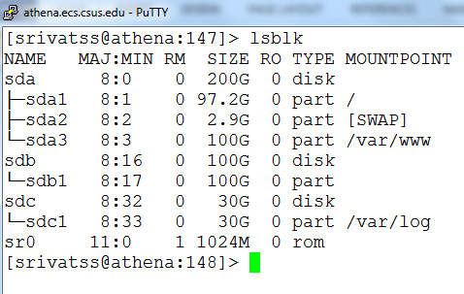

and you get the above information. The device drivers usr the major and minor numbers uniquely identify the partition, the major and minor numbers each are 16bit numbers. We will ignore this for now. We look at the mounts points which is what we should be looking. These partitions are mapped to a path using which we access the partitions.

Files are stored in a partition, partitions are formatted, and the formatted devices are mounted to a folder name. User have access to mount points.

To see the various filesystems, we have a linux command – mount. I have piped the output of mount to /dev .

c-prog>mount | grep ^/dev

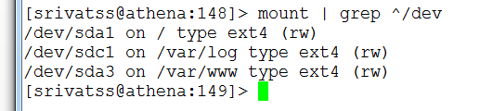

The process of redirecting the output of one command to another command is called piping and is represented as | ( vertical bar )

Note: ext2, ext3, ext4 are types of filesystems and the format is very different. Generally the boot is formatted in ext2 format.

You can also open the file /etc/fstab and this files shows all the mount points.

Disk usage:

df –hT

df displays the amount of disk space available on the file system, h stands for human readable format, T stands for Type. Currently, the output is seen as

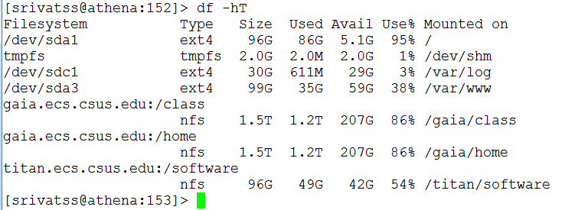

You can see the file system on the left, the size, used and availability and mount point.

What is ROOT: Root is the top most directory under which all other directories reside, note the actual file system they point may be on different file system. You can navigate to the root directory type

cd /

and navigate to sub-directories as shown in the screenshot.

Various file folders under Linux starting from root.

|  |  |
| --- | --- |
| Command | Comment |
| cd / | will take you to the root folder. do ls to see all folder. bin is one folder |
| cd /bin | here all basic shell commands exist. Commands such as ls, mkdir, pwd, |
| cd /sbin | here all system related commands exist. We will skip here |
| cd /home | All user accounts are stored. Staff accounts are stored in /home/staff/ and student accounts are stored in /home/student/ |
| cd /lib | all library files are stored here |
| cd /var | A folder to store temporary files ( usually log files which generally removed / purged after sometime) |
| cd /etc | Here important configurations system files are stored. Files such as user account and password ( /etc/passwd ) , file partitions ( etc/fstab ) |

Where is User Accounts and Password file:

The user ID, name, password, groupID and the default home directory and shell are stored in a file : /etc/passwd

If you open the file, each line looks like this,

ssrivatsa:x:2464:2470:Sankar Srivatsa:/home/student/ssrivatsa:/bin/bash

where

|  |  |
| --- | --- |
| ssrivatsa | user loginID |
| x | indicates presence of a password |
| 2464 | user ID |
| 2470 | group ID, accounts may belong to a group |
| full name | seen in the finger command, |
| /home/student/ssrivatsa | path to the home directory , one can change the default home directory to another directory using usermod command |
| /bin/bash | default shell program to launch during login |

You can get all these information using the command - finger loginid ( ex finger ssrivatsa)

You can get the user id and group id of yours using getuid ( ) and getgid ( ) functions

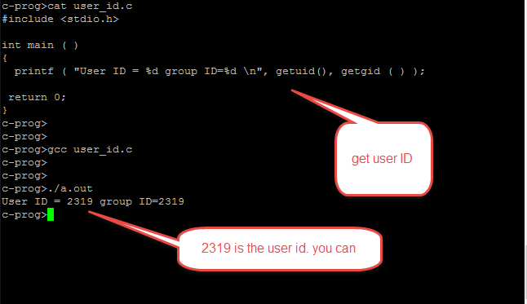

Where are C library files stored ?

Some of the header files you may use in your programs are stored in /usr/include folder. Navigate to /usr/include

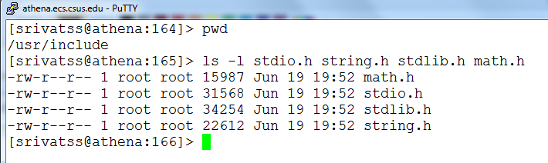

Types of Files and Directories:

There are two main types of files : regular files and directories. Technically, directories are stored as files , but we don’t see them as files, rather folders. The various types are

|  |  |
| --- | --- |
| Regular File | The most type of file. There is no distinction between binary or text file. The distinction to be made is left to the application |
| Directory File | A file that contains the names of other files and pointer to the information on these files. Any process that has read permissions can read the contents of the directory |
| Block special files | a type of file providing buffered IO to devices such as disk drives |
| Character file | a type of file providing unbuffered IO. |
| Socket file | Used for programming network communications (web…) |
| symbolic files | A type of file that points to another file.. |
| FIFO | used to communicate between processes |